**Annexure-I Term Paper**

**Oral Cancer Detection using Deep Learning**

**A Term Paper Report**

**Submitted in partial fulfilment of the requirements for the award of degree of Bachelor of Technology**

**(Computer Science Engineering) Submitted to**



# LOVELY PROFESSIONAL UNIVERSITY PHAGWARA, PUNJAB

**From 1st Sep 2024 to 3rd Nov 2024 SUBMITTED BY**

**Name of student: Jagadesh Chilla**

**Registration Number: 12110846**

**Faculty:** **Ajay Sharma**

**Annexure-II: Student Declaration To whom so ever it may concern**

I, **Jagadesh Chilla, 12110846**, hereby declare that the work done by me on **“Oral Cancer Detection Using Deep Learning”** from Sep 2024 to Nov 2024, is a record of original work for the partial fulfilment of the requirements for the award of the degree, Bachelor of Technology.

**Name of the student:** Jagadesh Chilla

**Registration Number:** 1210846

**Dated: 3rd November 2024**

# ACKNOWLEDGEMENT

Primarily I would like to thank God for being able to learn a new technology. Then I would like to express my special thanks of gratitude to the teacher and instructor of the course Machine Learning who provided me the golden opportunity to learn a new technology.

I would like to also thank my own college Lovely Professional University for offering such a course which not only improve my programming skill but also taught me other new technology.

Then I would like to thank my parents and friends who have helped me with their valuable suggestions and guidance for choosing this course.

Finally, I would like to thank everyone who have helped me a lot.

**Dated: 3rd November 2024**

**Table of Contents**

|  |  |  |
| --- | --- | --- |
| **S. No.** | **Contents** | **Page** |
| **1** | **Title** | **1** |
| **2** | **Student Declaration** | **2** |
| **3** | **Acknowledgement** | **2** |
| **4** | **Table of Contents** | **3** |
| **5** | **Abstract** | **4** |
| **6** | **Objective** | **4** |
| **7** | **Introduction** | **5-7** |
| **8** | **Theoretical Background** | **7-12** |
| **9** | **Hardware & Software** | **12-13** |
| **10** | **Methodology** | **13-33** |
| **11** | **Flowchart** | **14** |
| **12** | **Results** | **33** |
| **13** | **Summary** | **34** |
| **14** | **Conclusion** | **34** |
| **15** | **Bibliography** | **35** |
| **16** | **Annexure** | **36** |

**ABSTRACT**

Oral cancer poses significant health challenges worldwide, often leading to late diagnoses and poor prognoses. This project aims to enhance early detection through the development of a machine learning-based system capable of accurately classifying oral cancer images. Leveraging a dataset comprising 500 oral cancer images and 450 non-cancer images, we implemented several deep learning models, including Convolutional Neural Networks (CNN), ResNet50, DenseNet121, EfficientNetB2, and VGG19.

The models were trained and evaluated to identify the most effective architecture for oral cancer detection. Utilizing Streamlit, we created an interactive user interface that allows users to upload images and receive real-time predictions, making the technology accessible to healthcare professionals. Additionally, we deployed the application on Streamlit Cloud for easy access and utilized Docker to ensure consistent deployment across various environments.

This project not only demonstrates the potential of machine learning in medical imaging but also emphasizes the importance of early detection in improving patient outcomes. By providing a reliable tool for healthcare professionals, we aim to contribute to advancements in the diagnosis and treatment of oral cancer.

**OBJECTIVE**

The primary objective of this project is to significantly improve the early detection and diagnosis of oral cancer by developing a sophisticated machine learning-based classification model. Oral cancer often presents diagnostic challenges due to the subtle and complex variations in appearance between cancerous and non-cancerous tissues. Factors such as anatomical diversity, varying textures, colors, and the presence of lesions that can mimic benign conditions complicate the visual assessment process. Consequently, there is a pressing need for tools that can enhance diagnostic accuracy while minimizing the potential for human error.

To address this issue, the project aims to build an accurate and reliable deep learning model that can automatically classify oral images into cancerous and non-cancerous categories. By utilizing a comprehensive dataset consisting of 500 oral cancer images and 450 non-cancer images, the model will be trained to detect critical features indicative of oral cancer. These features may include nuances in color, texture, and overall morphology that may not be easily perceptible to the human eye.The project also emphasizes the automation of the diagnostic process. By reducing reliance on subjective human evaluations, it seeks to minimize diagnostic errors, lower the time required for assessment, and enhance the overall efficiency of oral cancer detection. Automating this process has the potential to significantly decrease the burden on healthcare professionals, allowing them to focus on more complex cases and patient care.

Additionally, this project intends to create an intuitive user interface using Streamlit, enabling healthcare practitioners to upload images and receive immediate predictions from the model. This feature not only enhances accessibility but also facilitates real-time decision-making in clinical settings.Ultimately, the successful development of this classification model represents a crucial step toward revolutionizing oral cancer diagnostics. It aims to establish a more efficient, accurate, and scalable diagnostic framework that can be integrated into clinical workflows, ultimately leading to improved patient outcomes through earlier and more reliable detection of oral cancer.

**INTRODUCTION**

1. **Background**

Oral cancer is one of the leading forms of cancer globally, characterized by the uncontrolled growth of cells in the oral cavity. Early diagnosis is crucial, as it significantly improves treatment outcomes and survival rates. Traditionally, oral cancer is diagnosed through clinical examinations, biopsies, and histopathological analysis. However, the manual evaluation of oral lesions can be challenging due to their subtle visual variations and the need for expert knowledge.The complexity and variability of oral lesions make automatic classification from images a daunting task. Machine learning and deep learning approaches have emerged as promising tools for enhancing diagnostic accuracy by analyzing medical images and identifying patterns that may be overlooked by human observers. This project leverages advanced image classification techniques to develop an automated system capable of detecting oral cancer from images, thereby facilitating timely interventions and improving patient care.

* What is **Oral Cancer?**

**Oral Cancer** is the abnormal growth of cells within the oral cavity, including the lips, tongue, cheeks, and throat. It can develop in areas that are frequently exposed to risk factors, such as tobacco use and alcohol consumption, but it can also appear in regions not typically associated with these behaviors.Cancer arises when healthy cells undergo mutations and begin to proliferate uncontrollably, forming a mass known as a tumor. These tumors can be classified as either malignant or benign. Malignant tumors, which are cancerous, have the potential to invade neighboring tissues and spread to other parts of the body. Conversely, benign tumors may grow in size but remain localized and do not invade surrounding tissues or metastasize.

The characteristics of tumors can vary significantly; benign tumors usually have well-defined, smooth borders, while malignant tumors often have irregular edges and tend to grow more rapidly. Oral cancer can manifest in various forms, and it is crucial for early detection and treatment to improve patient outcomes.

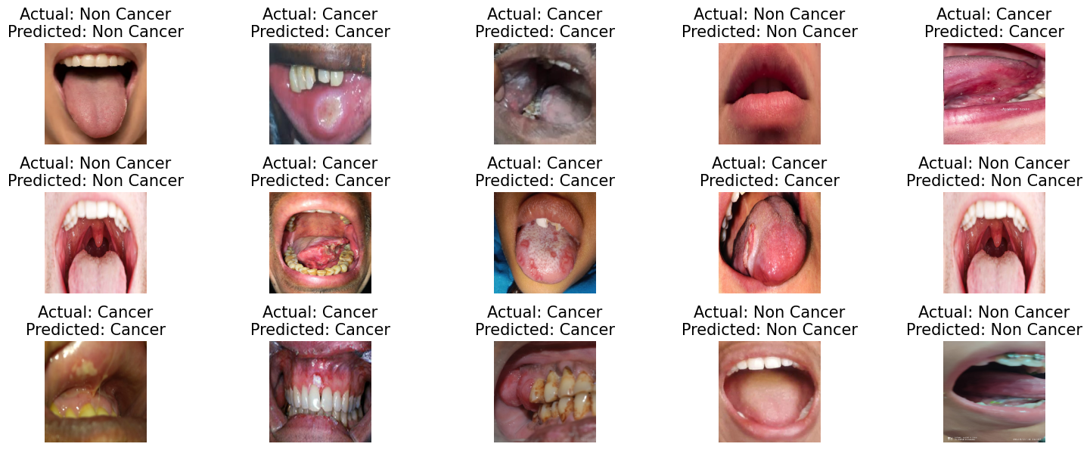

Figure 1: Real Data Images

1. **Other Types of Oral Cancer**

Oral cancer encompasses a variety of malignancies that can occur in different parts of the oral cavity. The most common types include:

* **Squamous Cell Carcinoma (SCC)**: The most prevalent form, SCC originates in the squamous cells lining the mouth and throat. It accounts for approximately 90% of oral cancers.
* **Oral Cavity Cancer**: This type refers to cancers that develop in the lips, gums, tongue, and the inner lining of the cheeks.
* **Salivary Gland Cancer**: Although less common, cancers can arise in the salivary glands, which produce saliva and help with digestion.
* **Lymphoma**: While primarily affecting the lymphatic system, lymphomas can also manifest in the oral cavity.
* **Melanoma**: Rare in the mouth, melanoma originates from pigment-producing cells and can appear as dark lesions in the oral cavity.

1. **Causes of Oral Cancer**

The development of oral cancer is influenced by various risk factors, including:

* **Tobacco Use**: Smoking or chewing tobacco significantly increases the risk of oral cancer, contributing to mutations in the oral mucosa.
* **Alcohol Consumption**: Heavy alcohol use is associated with a higher risk, particularly when combined with tobacco.
* **Human Papillomavirus (HPV)**: Certain strains of HPV, particularly HPV16, are linked to the development of oral cancers.
* **Sun Exposure**: Overexposure to sunlight can lead to cancers of the lips.
* **Poor Oral Hygiene**: Chronic irritation or inflammation in the mouth from poor dental care can contribute to cancer development.
* **Diet**: A diet low in fruits and vegetables may increase the risk of oral cancers.

1. **Existing Cures and Remedies for Oral Cancer**

Treatment for oral cancer depends on the stage and location of the disease and can include:

* **Surgery**: The removal of cancerous tissue is often the primary treatment. This may involve removing part or all of the affected area.
* **Radiation Therapy**: High-energy radiation is used to kill cancer cells, either alone or in combination with other treatments.
* **Chemotherapy**: This involves the use of drugs to kill cancer cells and is often used for advanced cases.
* **Targeted Therapy**: Newer treatments that target specific pathways involved in cancer growth and spread.
* **Immunotherapy**: Treatments that help the body’s immune system fight cancer.

1. **Need for Machine Learning**

The integration of **machine learning** in oral cancer detection and treatment is essential due to several reasons:

* **Early Detection**: Machine learning algorithms can analyze medical images and detect patterns that may indicate early signs of cancer, leading to timely diagnosis.
* **Improved Accuracy**: By training models on large datasets, machine learning can enhance diagnostic accuracy, reducing the likelihood of human error in interpretation.
* **Personalized Treatment Plans**: Machine learning can help identify the most effective treatment options for individual patients based on their specific cancer characteristics and responses to previous therapies.
* **Resource Optimization**: Automated analysis can streamline workflows in clinical settings, allowing healthcare professionals to focus on patient care rather than time-consuming image evaluations.
* **Research Advancements**: Machine learning aids in the analysis of vast amounts of data, fostering research and development in oral cancer therapies and preventive measures.

By harnessing the power of machine learning, we can significantly improve the management of oral cancer, ultimately leading to better patient outcomes and enhanced survival rates.

**THEORETICAL BACKGROUND**

1. What is **Artificial Neural Network?**

An artificial neural network (ANN) is a form of machine learning model inspired by the human brain. ANNs can learn complicated patterns from data and have been demonstrated to be very effective in a range of applications such as image classification, natural language processing, and speech recognition.

ANNs are composed of artificial neurons that are linked together. The artificial neurons are organised in layers, with each layer performing a specific purpose. The data is received by the input layer, the hidden layers analyse the data patterns, and the predictions are produced by the output layer.

1. What is **Deep Learning**?

Deep learning is a subset of machine learning that learns from data using artificial neural networks. Deep learning has been utilised to produce cutting-edge solutions in a wide range of applications, including image recognition, natural language processing, and speech recognition. Deep learning models are mostly made up of several layers of artificial neurons. Each unit of neurons receives the previous layer's output as input and generates a response that is sent into the following layer. During training, the weights of the neural networks are trained, allowing the model to learn connections between the data input and the predicted output. Deep learning outperforms classic machine learning techniques in various ways.

For starters, deep learning can understand complicated patterns and correlations in data that typical machine learning approaches would struggle to learn. Second, deep learning can learn from enormous volumes of data, which can enhance the accuracy of predictions. Third, deep learning generalises well to new data, it means it can make correct predictions on data it has never seen before.

1. What is **Convolutional Neural Network?**

Convolutional neural networks (CNNs) are artificial neural networks that are specifically designed to process input with a grid-like structure, like images. CNNs can learn spatial correlations between image pixels, making them ideal for image classification, object recognition, and segmentation.

CNNs are constructed up of layers, and each one serves a distinct purpose. The convolutional layer is the initial layer of a CNN and is responsible for obtaining the image's features. The convolutional layer scans the image as input and extracts features using a filter, which is a tiny matrix of weights. The features retrieved by the convolution layers are passed on to the pooling layer. The pooling layer is in charge of narrowing the feature size map, which aids in lowering the network's computational complexity. To lower the size of the feature map, the pooling layer employs a pooling technique such as max pooling or average pooling.

Fully connected is the subsequent layer in a CNN. The fully connected layer is a typical neural network layer in which each neuron is linked to every neuron in the previous layer. The fully connected layer is in charge of categorising the input image. The fully connected layer employs a SoftMax function to generate a probability distribution across the various classes. CNNs have been demonstrated to be extremely effective for a wide range of applications, including image classification, object identification, and segmentation. CNNs are employed in many different applications, including self-driving automobiles, medical image analysis, and facial recognition.

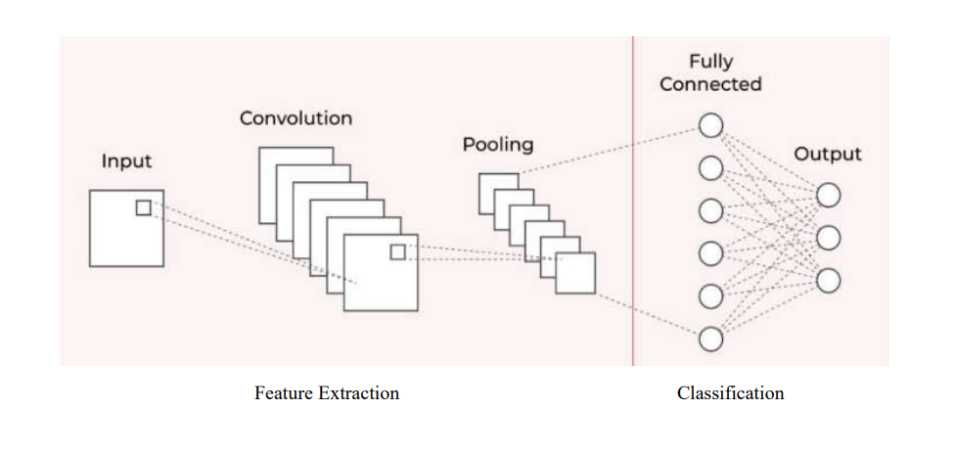

Figure 2: CNN Model

1. What is **ResNet 50?**

**ResNet50 (Residual Networks)** is a deeper network with 50 layers that incorporates **residual connections** (or skip connections) to solve the vanishing gradient problem common in deep networks. This makes it highly effective for complex tasks like medical image classification.

* **Advantages**: The residual connections enable the network to learn much deeper representations without degrading performance.
* **Use Case**: ResNet50 excels in detecting intricate patterns in medical images, making it a great candidate for identifying cancerous tissues.
* **Limitations**: As the network becomes deeper, it requires more computation power, increasing the time required for training.

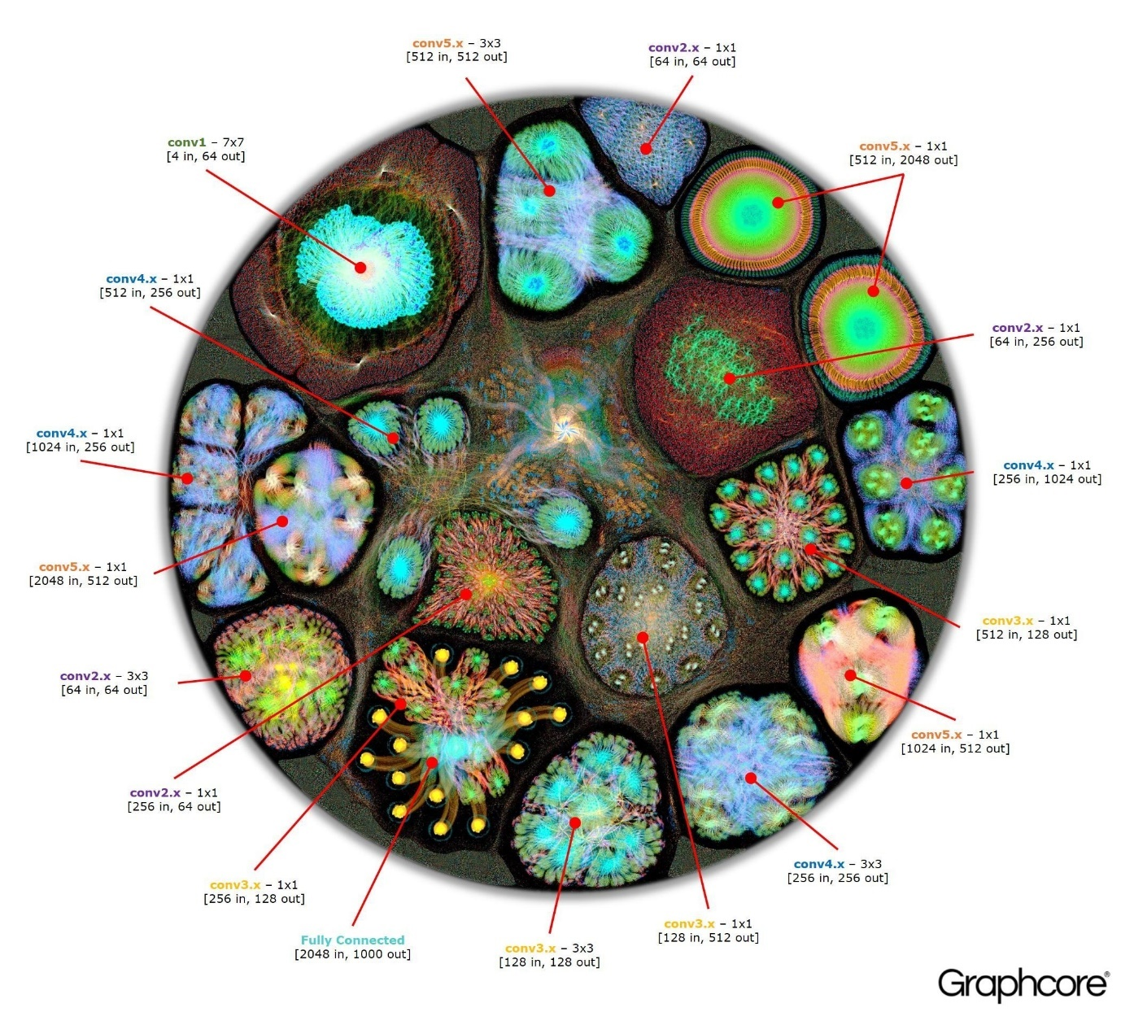

Figure 3:Resnet50 Model

1. What is **DenseNet121**?

**DenseNet121 (Densely Connected Convolutional Networks)** employs dense blocks, where each layer is directly connected to every other layer, allowing feature reuse and improving efficiency.

* **Advantages**: DenseNet121 captures detailed information by reusing features, which can help the model efficiently learn the critical features needed for cancer detection.
* **Use Case**: Its ability to learn complex features makes it well-suited for cancer detection, as it captures small yet significant features in oral images.
* **Limitations**: DenseNet can be computationally demanding, especially when dealing with large datasets.

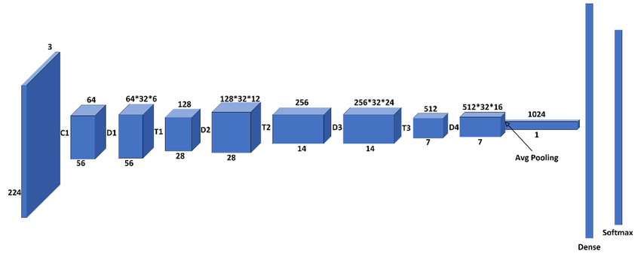

Figure 4:DenseNet121 Model

1. What is **EfficientNetB2**?

**EfficientNetB2** is part of the EfficientNet family, which scales model dimensions—width, depth, and resolution—in a balanced manner, optimizing performance while using fewer parameters.

* **Advantages**: EfficientNetB2 provides high accuracy with fewer parameters, which is beneficial for resource-constrained environments (e.g., mobile applications or cloud-based deployments).
* **Use Case**: Its efficiency and accuracy make it an ideal choice for real-time cancer detection tasks where computational resources may be limited.
* **Limitations**: While it uses fewer parameters, EfficientNetB2 may still require considerable tuning and experimentation to optimize performance on highly complex tasks.

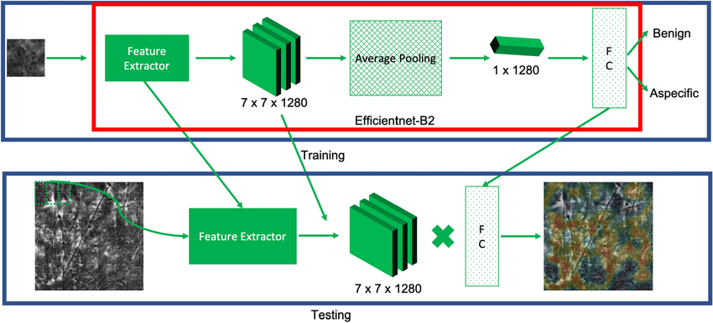

Figure 5:EfficientNetB2 model

1. What is **VGG19?**

**VGG19** is a very deep network with 19 layers, known for its simplicity and high performance in transfer learning tasks. It’s frequently used in medical imaging tasks due to its ability to generalize well from pretrained weights.

* **Advantages**: VGG19 is straightforward in architecture and powerful when fine-tuned on specific tasks, such as detecting cancer in oral images.
* **Use Case**: It’s often used for transfer learning, leveraging pretrained weights to adapt quickly to the specific task of oral cancer detection.
* **Limitations**: VGG19 is resource-intensive and slower compared to other models, which can make training and inference more time-consuming.

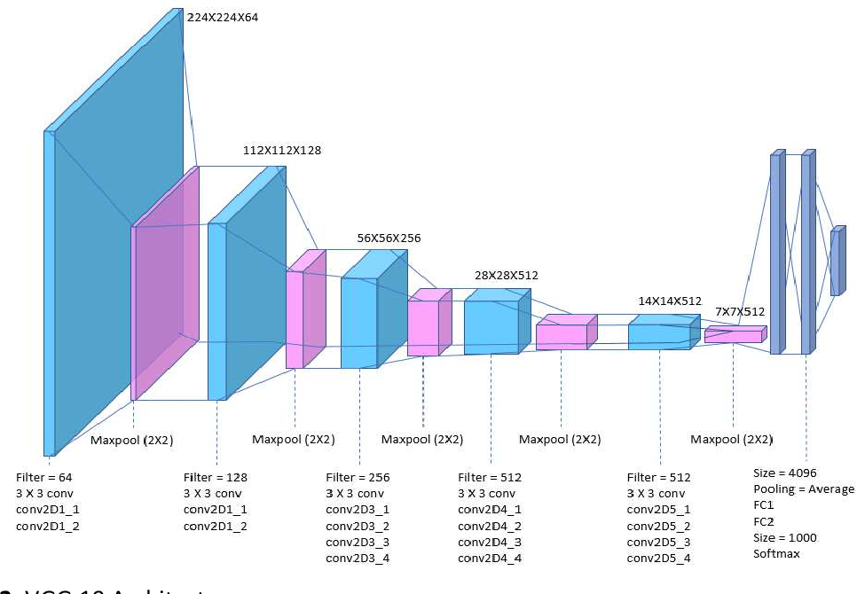

Figure 6:Vgg19 Model

1. **Image Classification** using **Deep Learning**

Image classification is a form of machine learning problem in which the objects or events in an image are identified. It is a difficult task because images might be complicated and contain several items. Deep learning, on the other hand, has made image classification far more precise and efficient. There are numerous deep learning architectures available for image classification. The convolutional neural network is a popular architecture (CNN). CNNs are ideal for image classification because they can learn spatial correlations among pixels in an image.

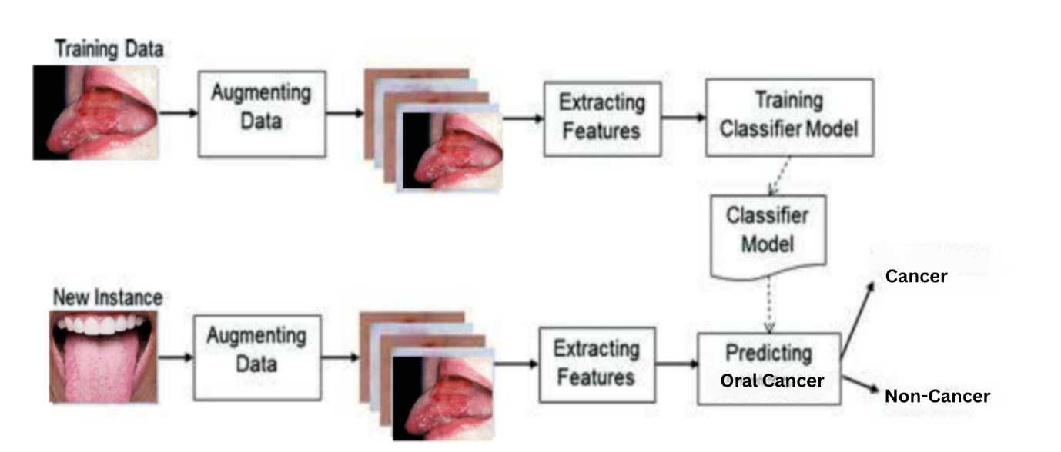

Figure 7: Oral Cancer Classification Model Working

1. Benefits of using **Deep Learning Model for Classification**

* Deep learning models can recognise minor details that humans cannot perceive.
* Deep learning models can be trained on massive image datasets, so they can learn more generalizable features.
* Deep learning models can be utilised to create automated screening systems for oral cancer.

1. Challenges in using **Deep Learning Model for Classification**

* Deep learning models need to be trained on huge datasets of labelled data.
* Deep learning models can be complex to train and deploy in terms of computational power.
* Deep learning models are prone to overfitting.

**Hardware & Software Requirements**

**Hardware**

Tensor Processing Units (TPUs), or graphics processing units (GPUs): Deep learning model training is a good fit for these specialist processors' parallel processing capabilities. When compared to using conventional CPUs, GPUs and TPUs can greatly accelerate the training process.

**Software**

Python: Python is a well-liked machine learning programming language with a wide variety of tools and frameworks for creating models. TensorFlow and scikit-learn are a few well-liked libraries for spotting skin cancer.

Frameworks for deep learning: These are software collections that offer resources for creating and refining deep learning models. TensorFlow and Keras are a few popular deep learning frameworks for the diagnosis of skin cancer

**METHODOLOGY**

**• Importing required Libraries**

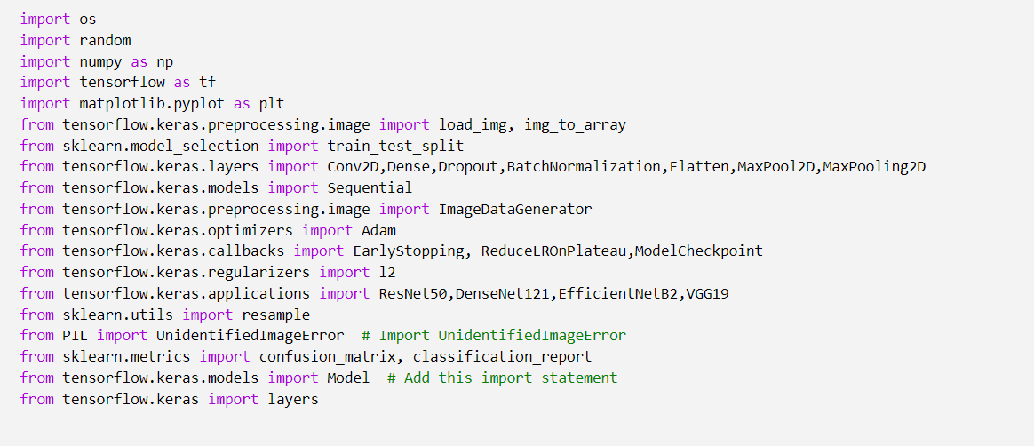

**Libraries and Modules**:

* **os**: Used for interacting with the operating system (e.g., file paths).
* **random**: Used for generating random numbers (often for shuffling data).
* **numpy**: A library for numerical operations and handling arrays.
* **tensorflow**: An open-source library for machine learning, particularly deep learning.
* **matplotlib.pyplot**: A plotting library for visualizing data, especially for displaying images and model performance.
* **PIL**: Used for image processing, specifically for handling errors related to image loading.

**Deep Learning Model Architecture**:

* **Sequential**: A Keras model that allows stacking layers in a linear fashion.
* **Conv2D, MaxPooling2D**: Layers for building convolutional neural networks (CNNs), essential for feature extraction from images.
* **Dense, Dropout, BatchNormalization**: Layers for creating fully connected networks, preventing overfitting, and normalizing inputs.
* **Flatten**: A layer that converts multi-dimensional data into a single dimension.
* **Regularization**: Using **l2** regularization to prevent overfitting.

**Pre-trained Models**:

* **ResNet50, DenseNet121, EfficientNetB2, VGG19**: These are pre-trained deep learning architectures used for transfer learning to leverage their learned features for the current task.

**Evaluation Metrics**:

* **confusion_matrix, classification_report**: Functions from scikit-learn to assess model performance on the test set.

**Flow Chart**

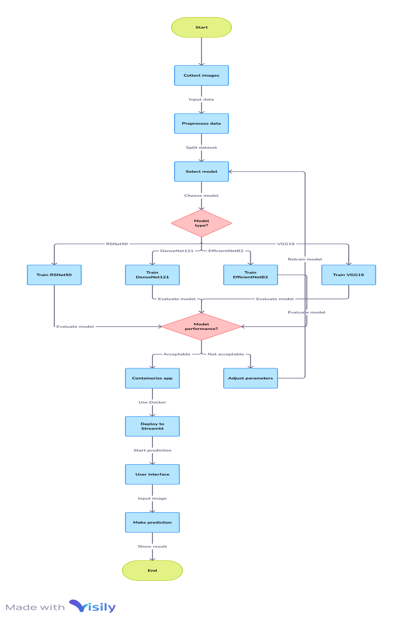

FlowChart1:Project Flow

* **Data Collection and Inspection of dataset**

About the Dataset

Introducing the Oral Cancer Image Dataset! This dataset comprises 500 oral cancer images and 450 non-cancer oral images, all meticulously labeled for seamless classification. The dataset is designed to support research and development in the field of oral cancer detection using advanced machine learning algorithms.

With a balanced representation of cancer and non-cancer samples, it allows researchers to explore innovative approaches to enhance diagnostic accuracy. This dataset serves as a valuable resource for the healthcare community, fostering advancements in early detection and intervention for oral cancer.

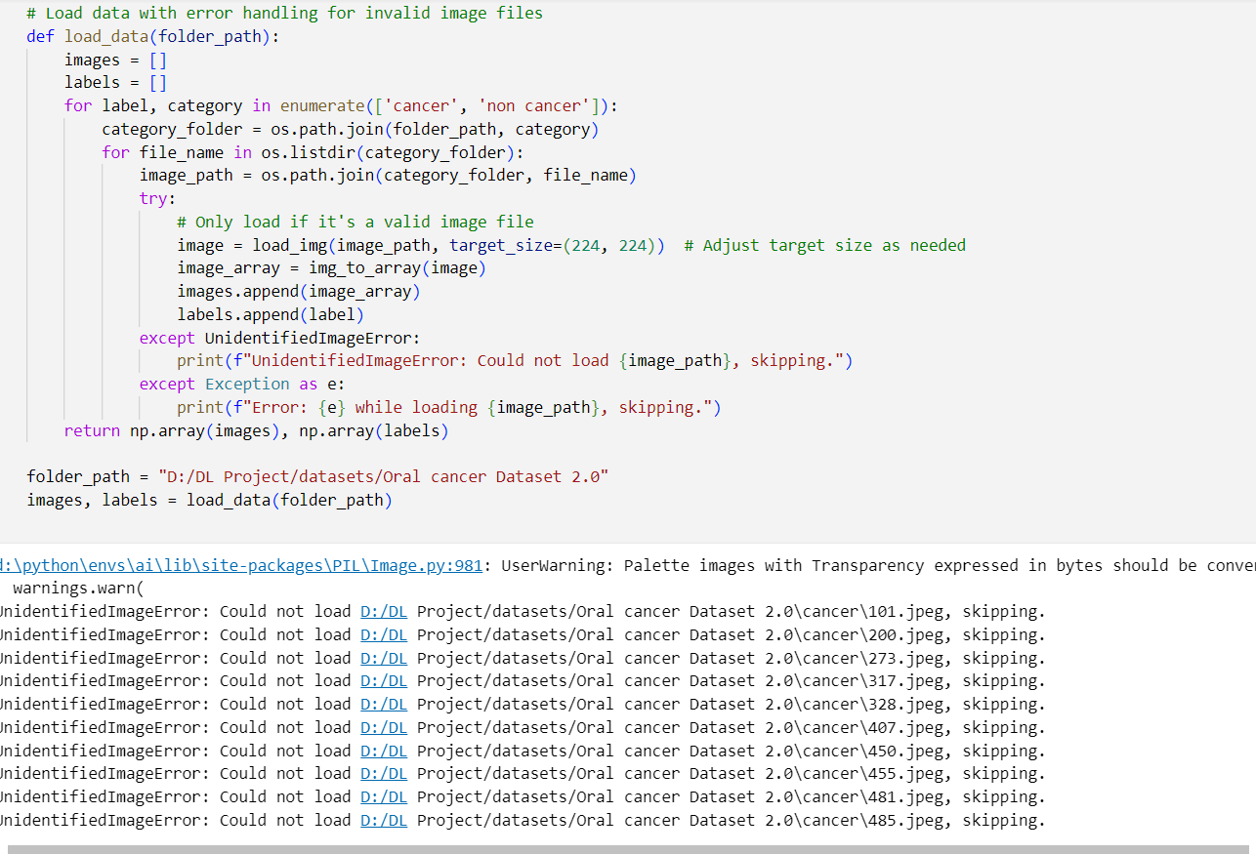

* **Split The Dataset for Training**



* **Building the Models**
  1. **CNN Model**

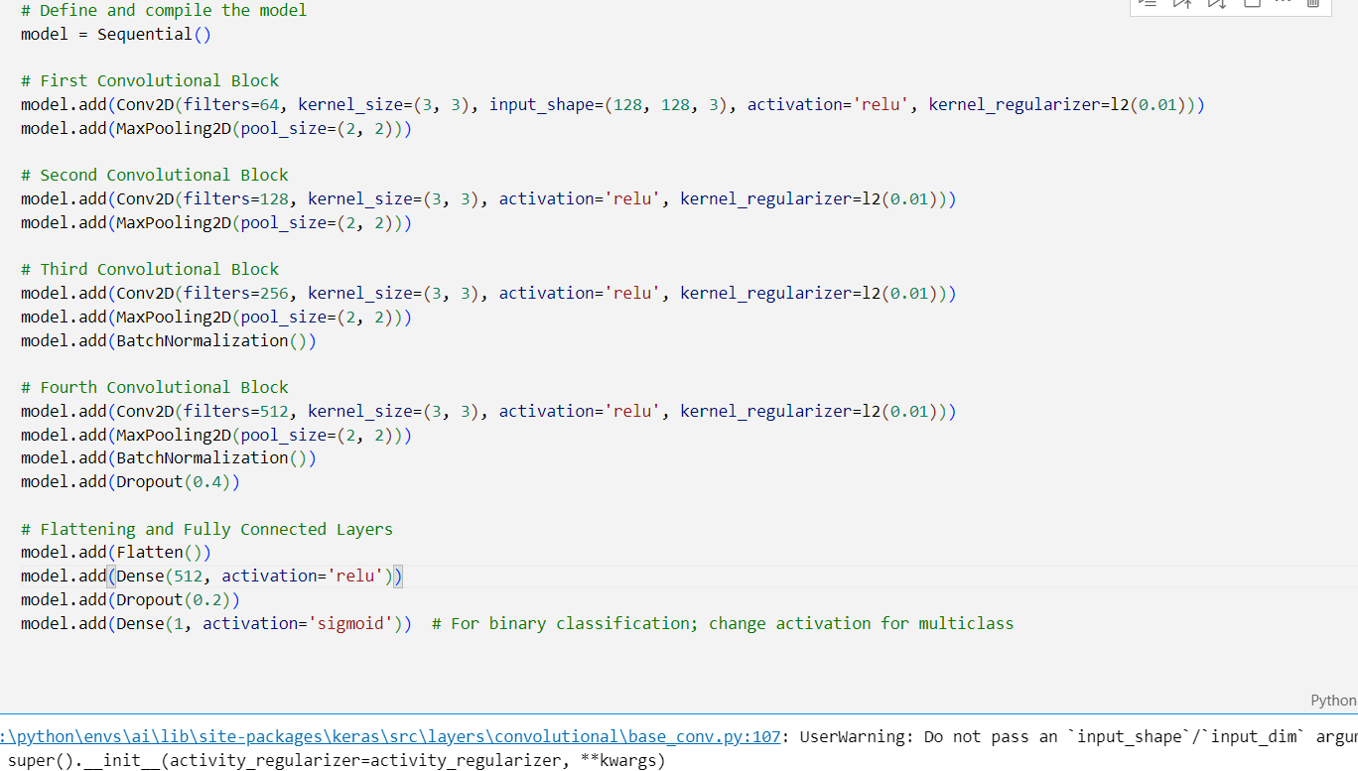

**Model Summary**

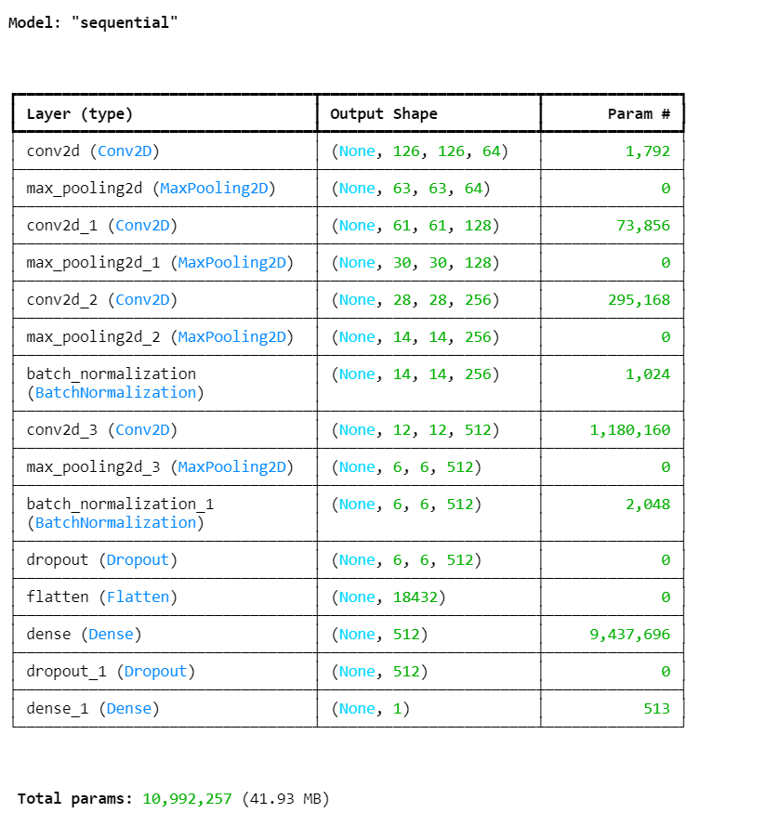

**Layers of CNN Model**

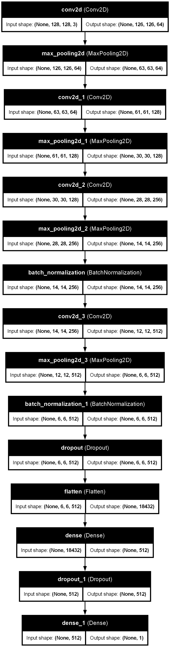

**Figure 8: CNN Model Architecture**

**Early Stopping Callback & Reduce Learning Rate Callback**

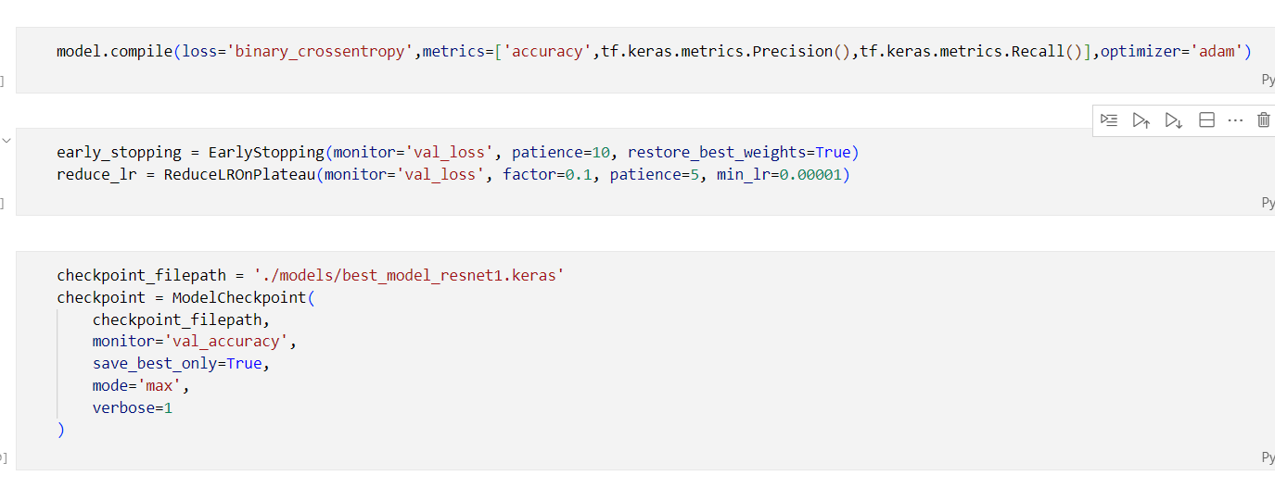

**Training CNN Sequential Model with Epoch**

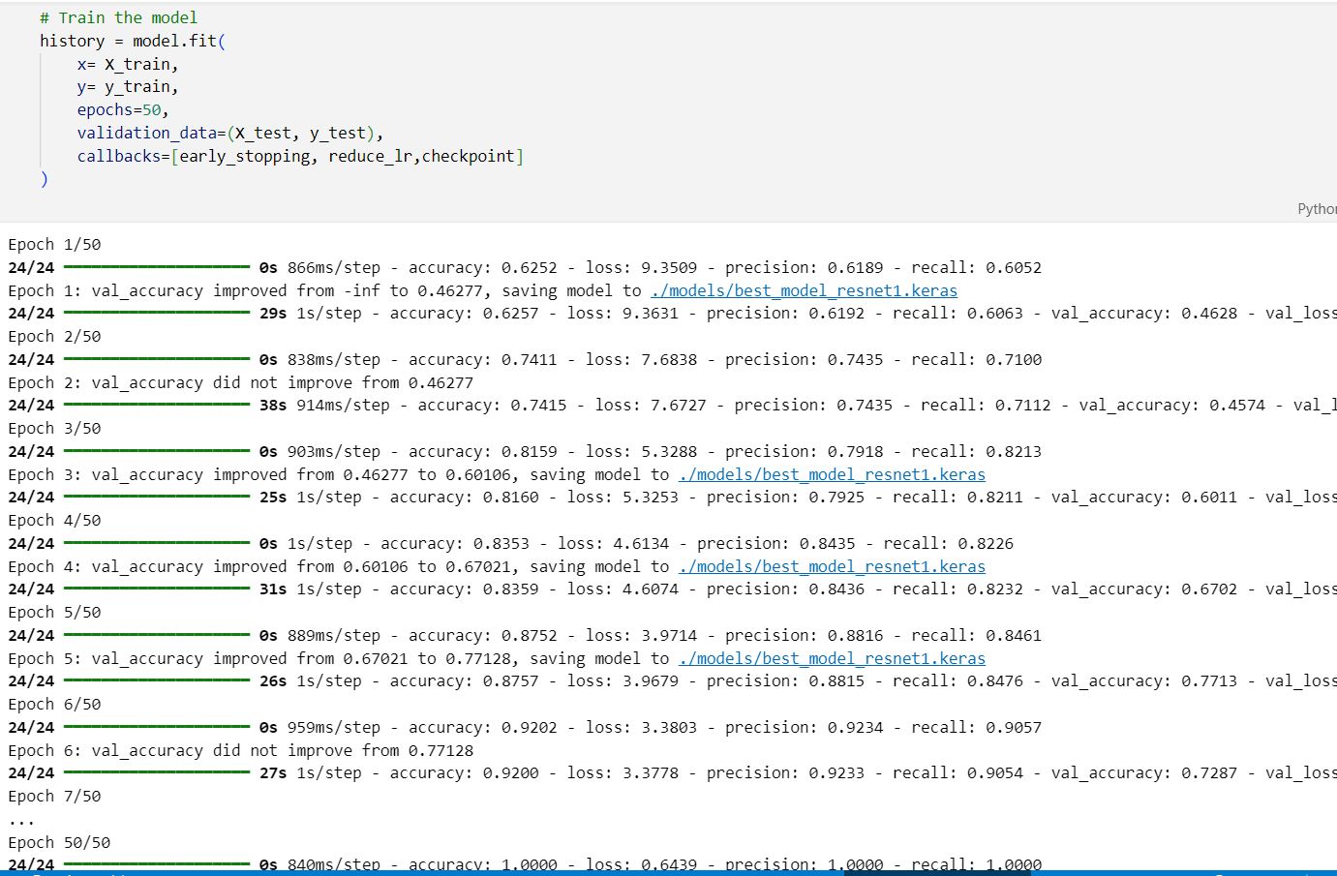

**Model Evaluation**

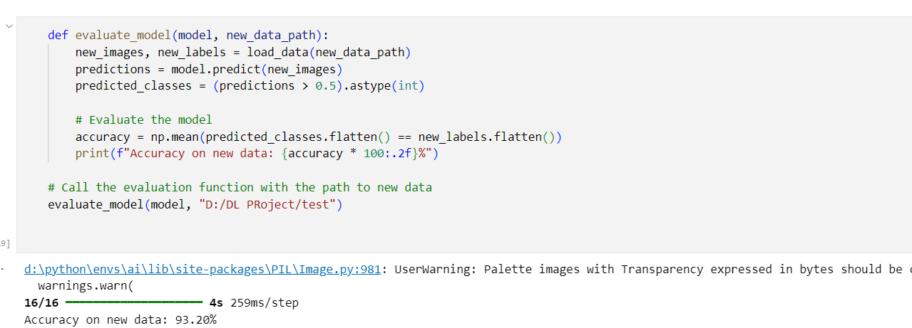

**Loss & Accuracy metrics for Model**

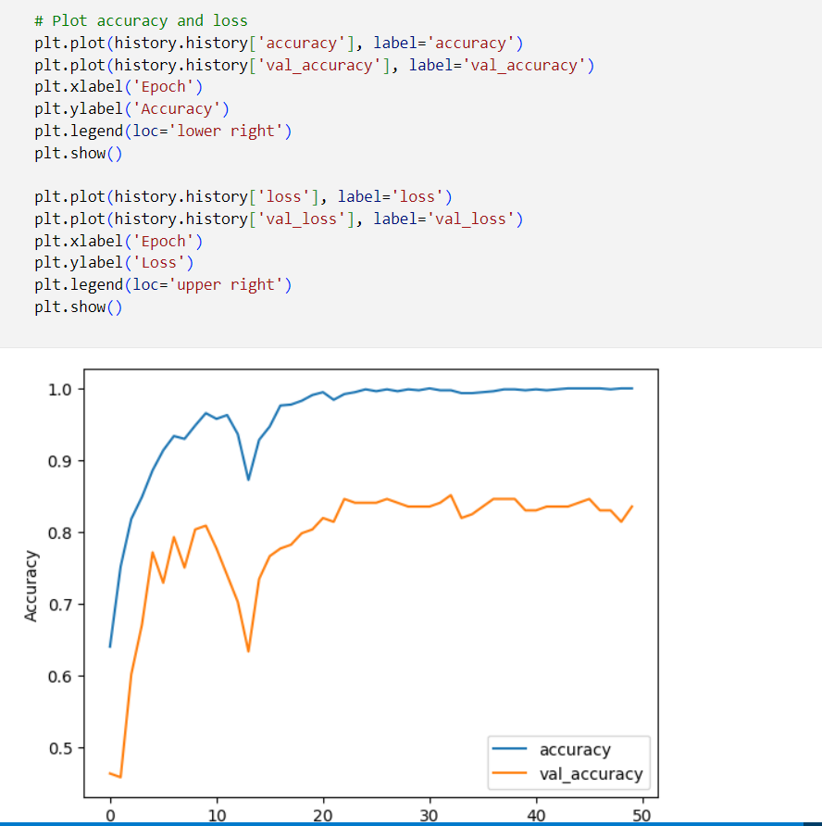

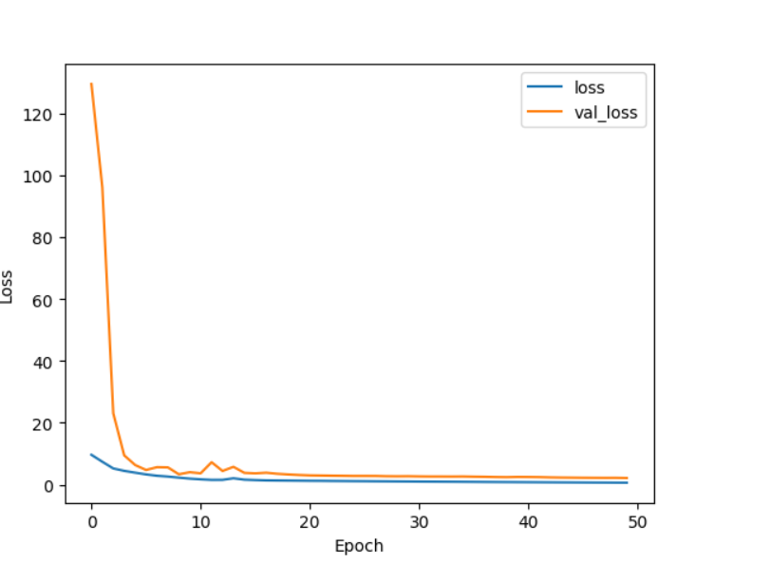

**Figure 9:** **Loss & Accuracy plots vs Epochs**

**Plotting Confusion Matrix**

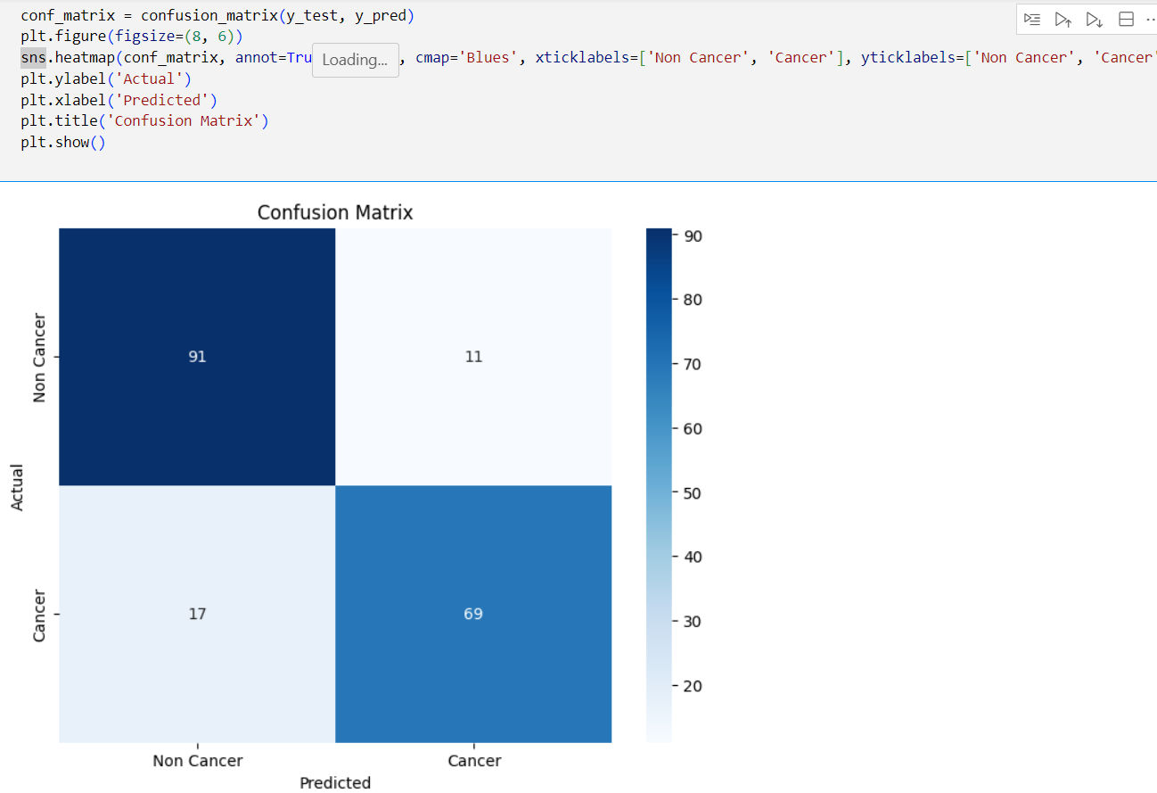

**Figure 10: Confusion Matrix-cnn**

**Plotting Classification Metrics & Performance Metrics**

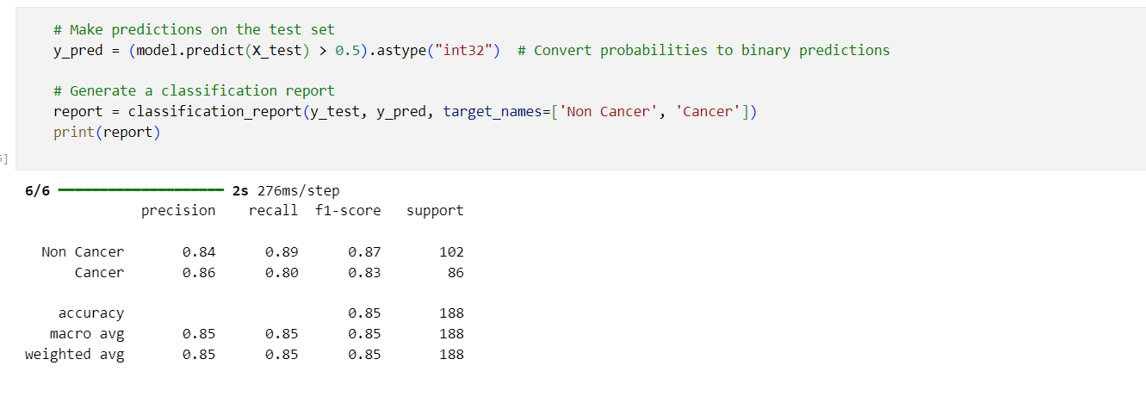

**Figure 11: Performance matrix-cnn**

* 1. **ResNet50 Model**

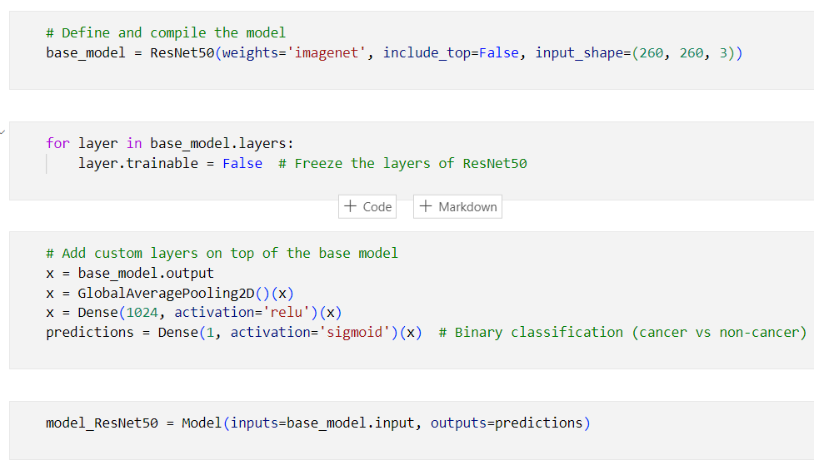

**Early Stopping Callback & Reduce Learning Rate Callback**

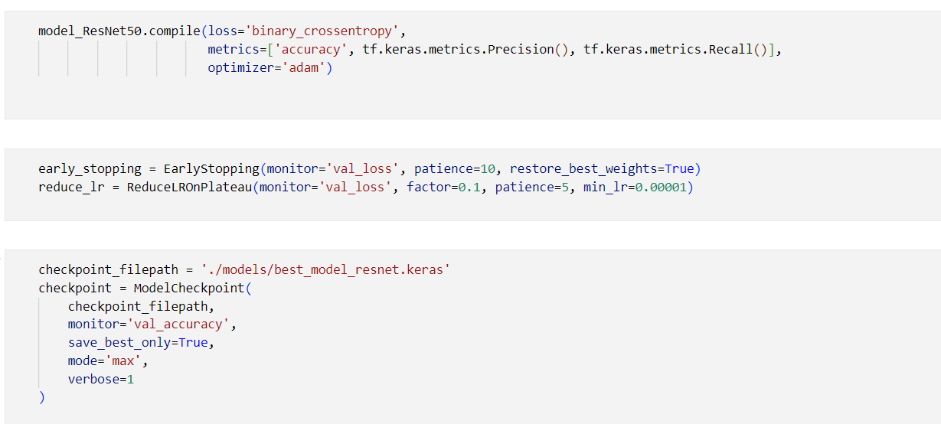

**Training ResNet Model with Epoch**

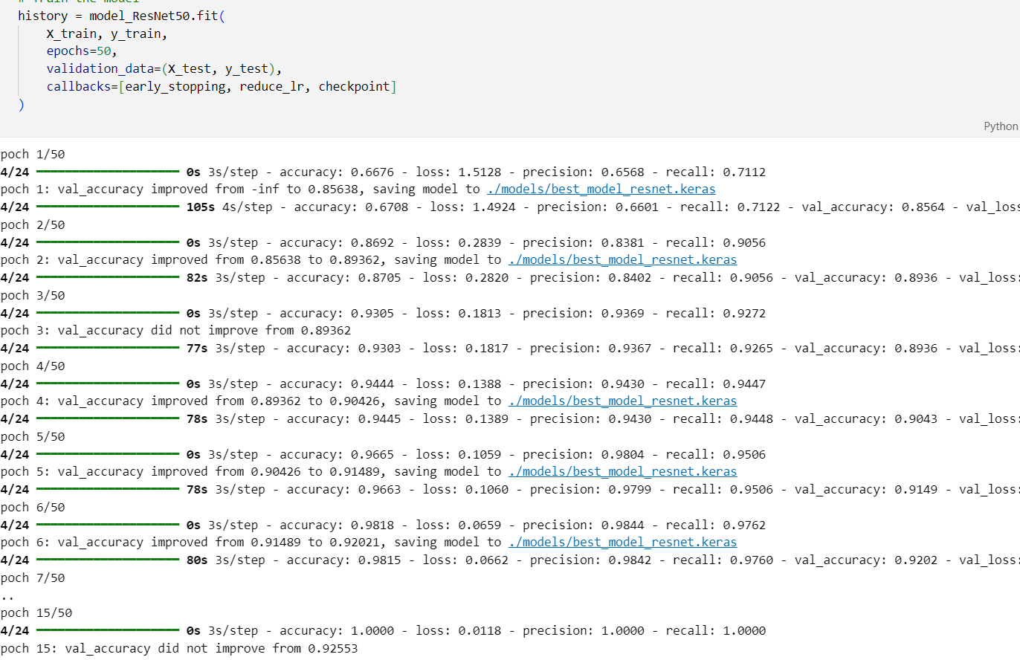

**Model Evaluation**

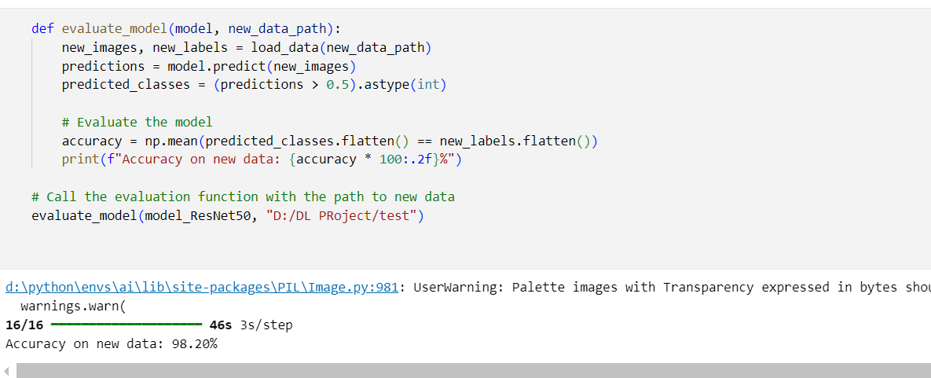

**Loss & Accuracy metrics for Model**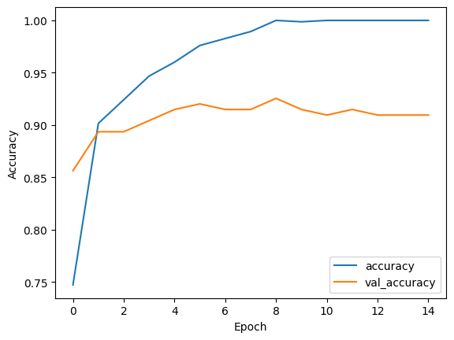

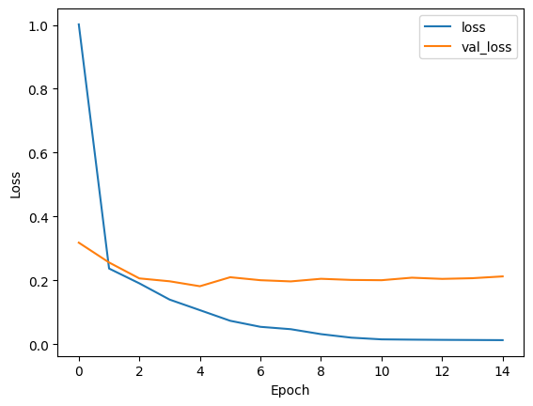

**Figure 12:** **Loss & Accuracy plots vs Epochs**

**Plotting Confusion Matrix**

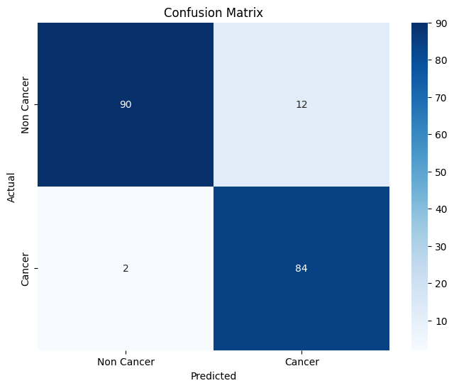

**Figure 13: Confusion Matrix-Rsenet**

**Plotting Classification Metrics & Performance Metrics**



**Figure 14: Performance matrix-rsnet**

* 1. **EfficientNetB2**

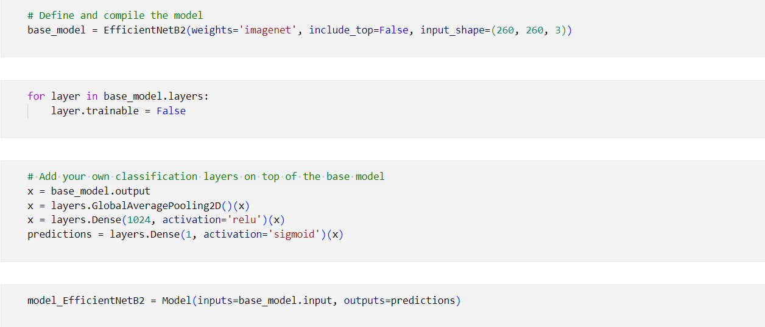

**Training EfficientNet Model with Epoch**

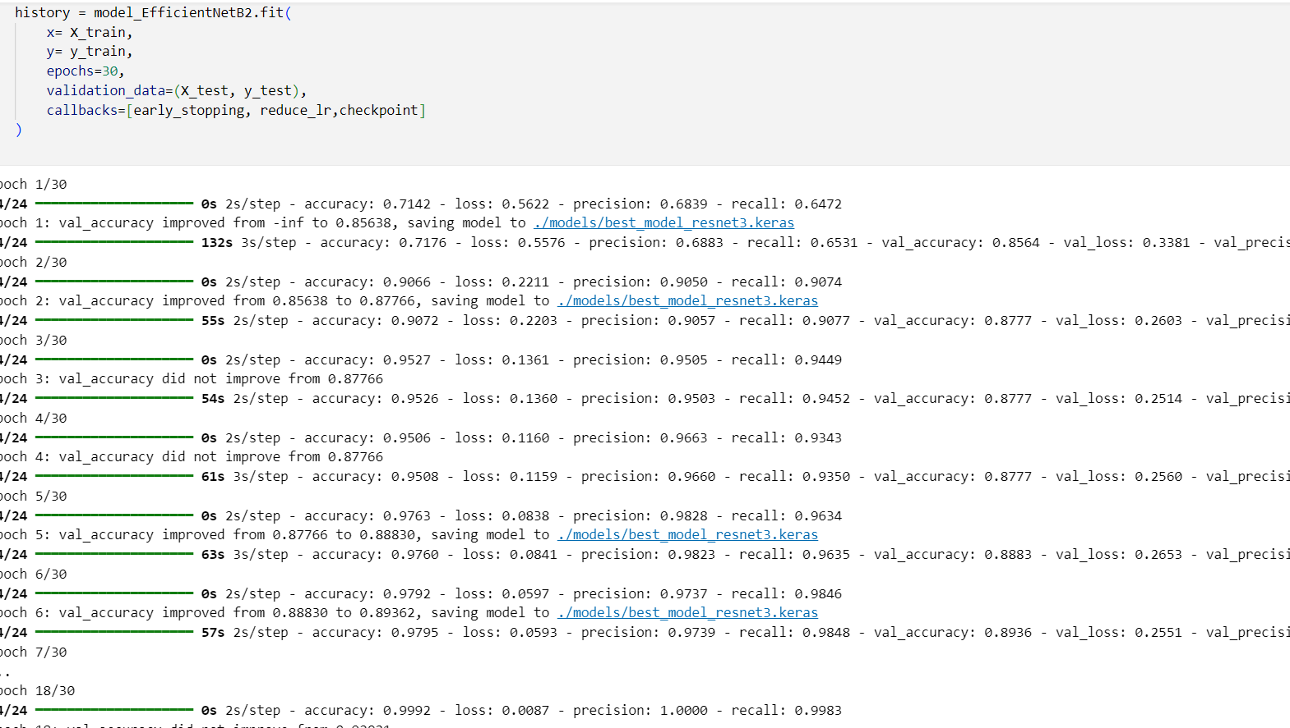

**Model Evaluation**

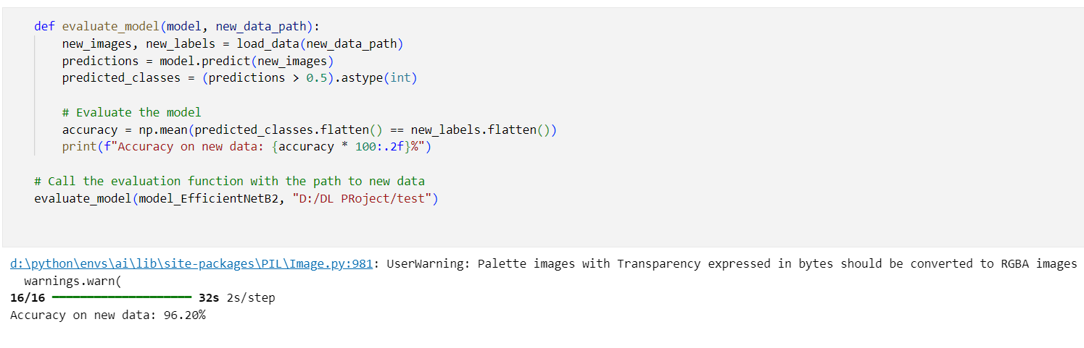

**Loss & Accuracy metrics for Model**

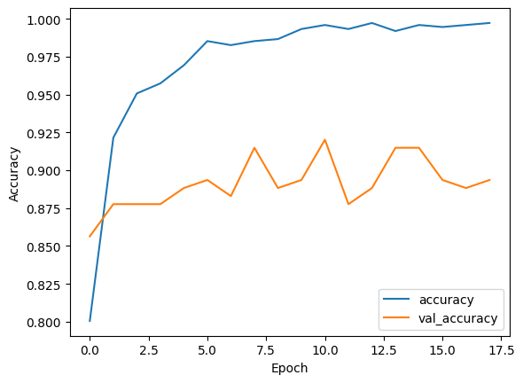

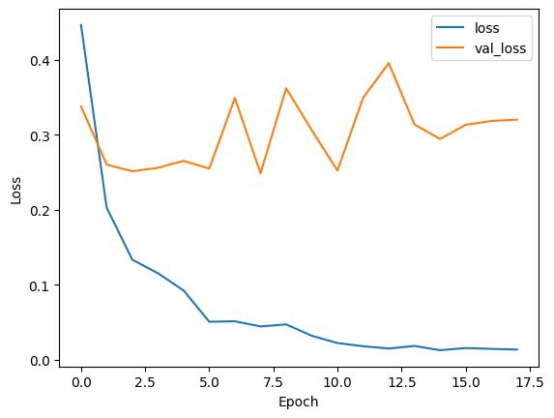

**Figure 15:** **Loss & Accuracy plots vs Epochs**

* 1. **DenseNet121**

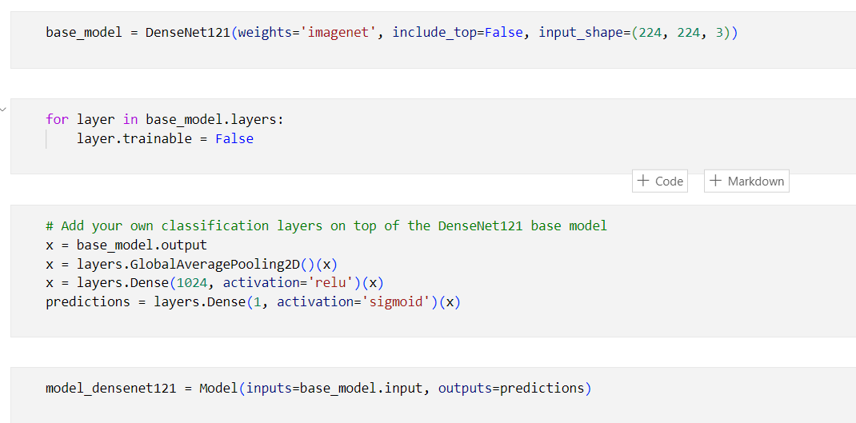

**Training DenseNet Model with Epoch**

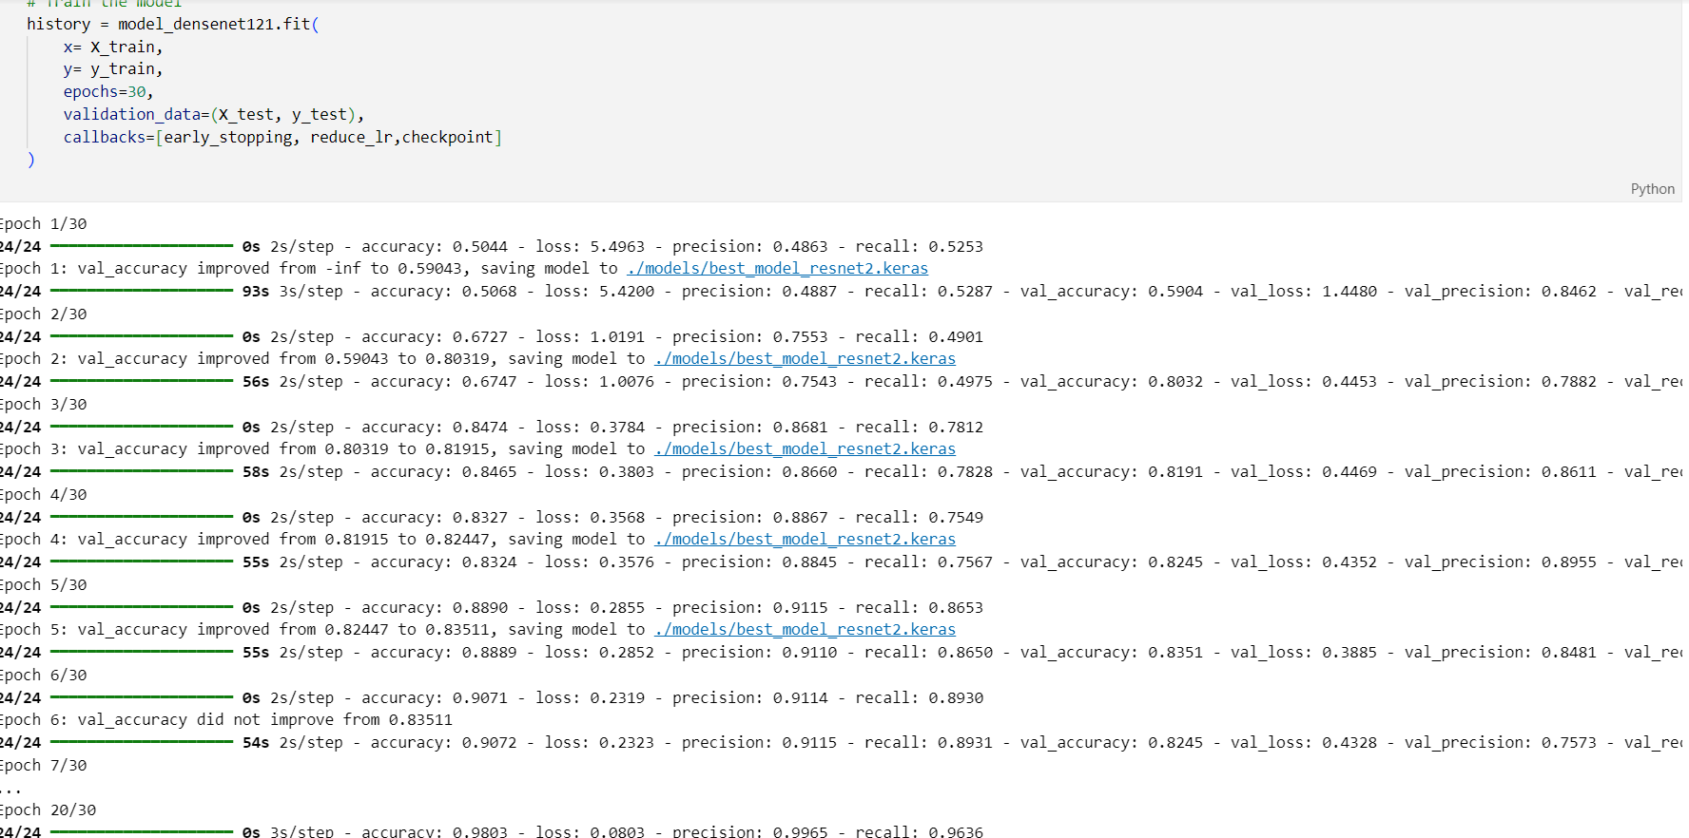

**Model Evaluation**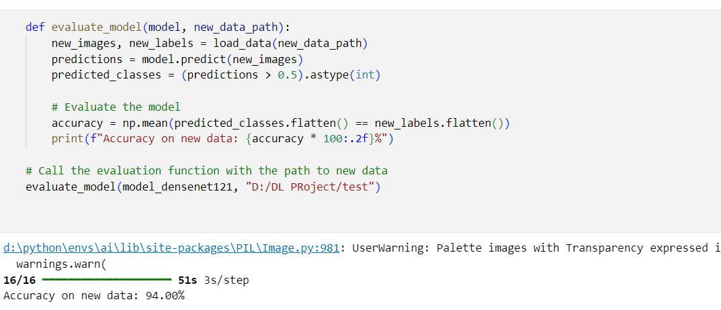

**Loss & Accuracy metrics for Model**

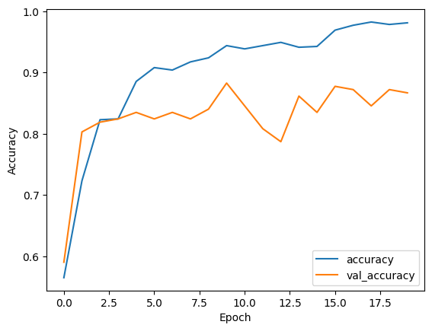

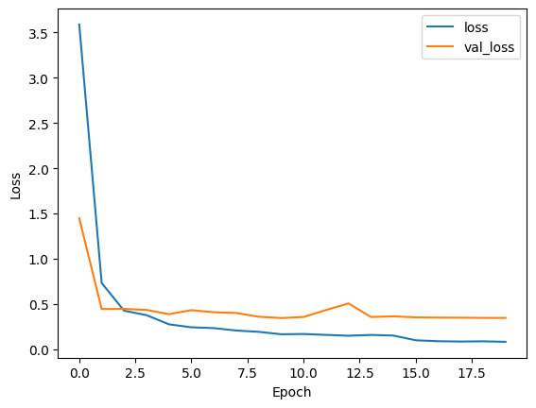

**Figure 16:** **Loss & Accuracy plots vs Epochs**

* 1. **VGG19**

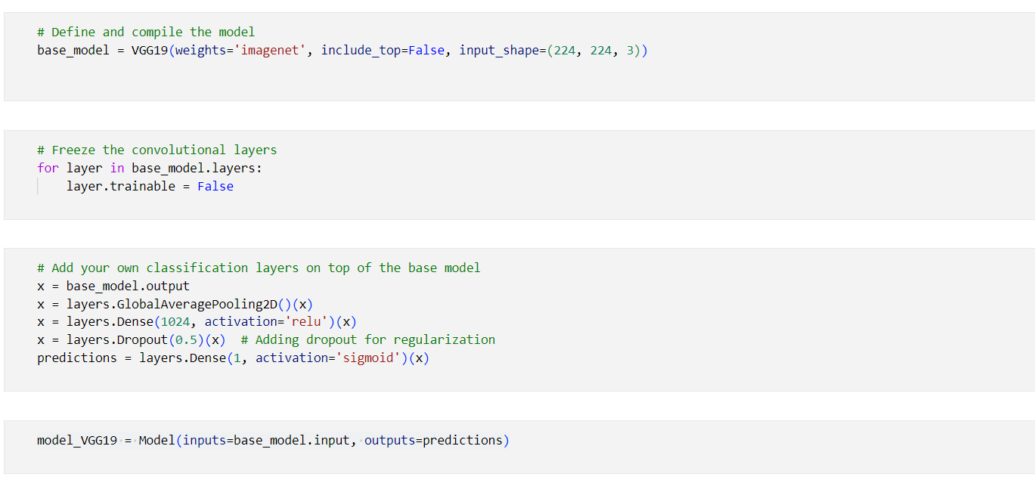

**Training vgg19 Model with Epoch**

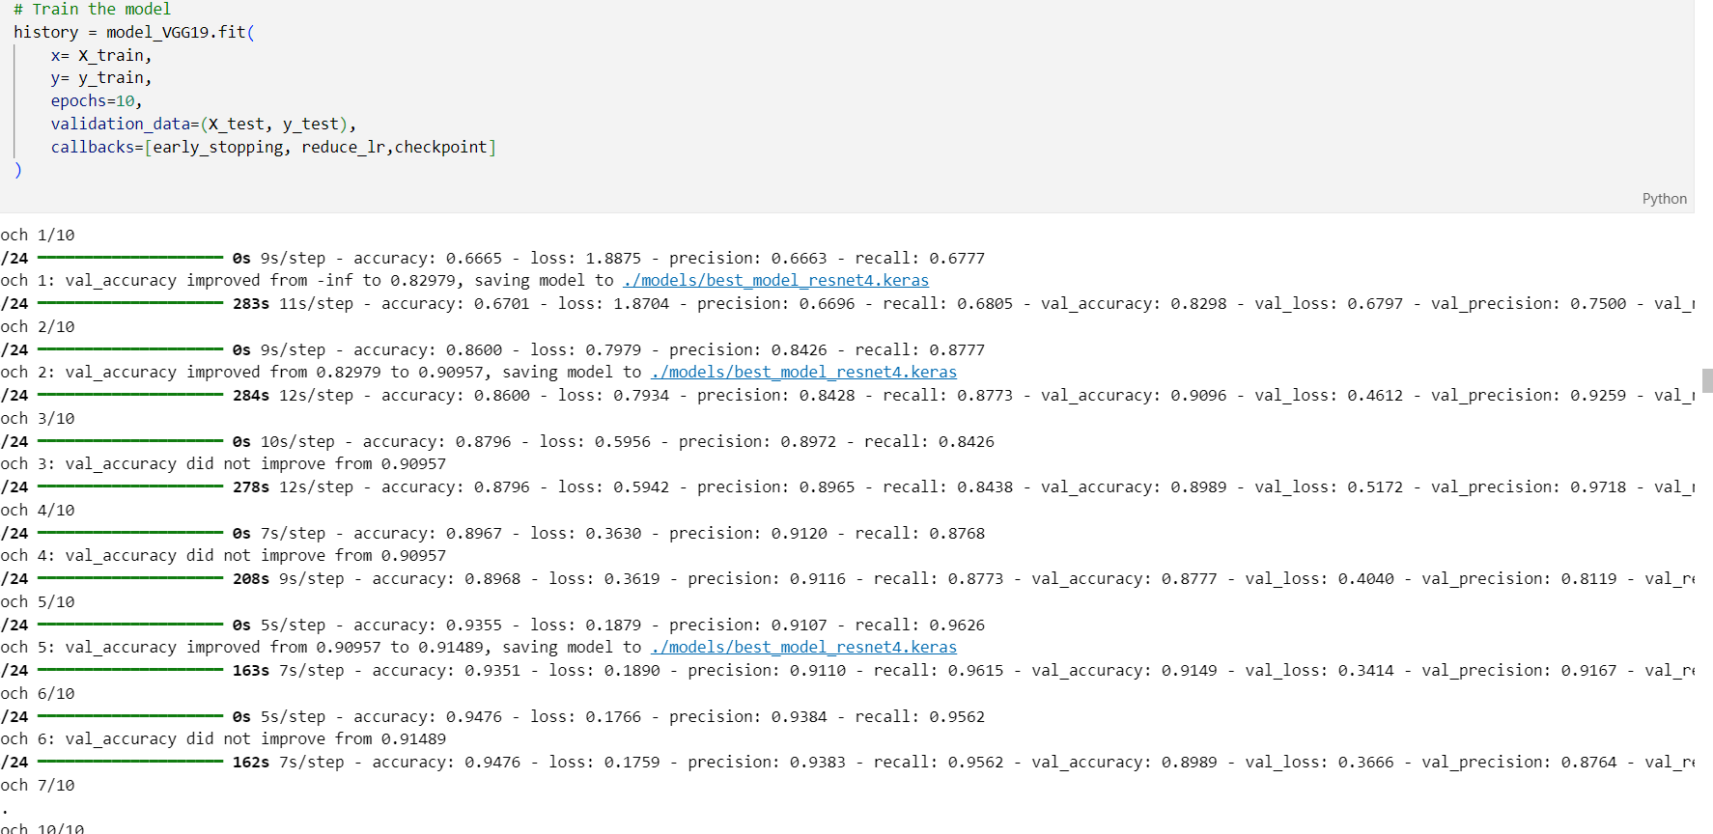

**Model Evaluation**

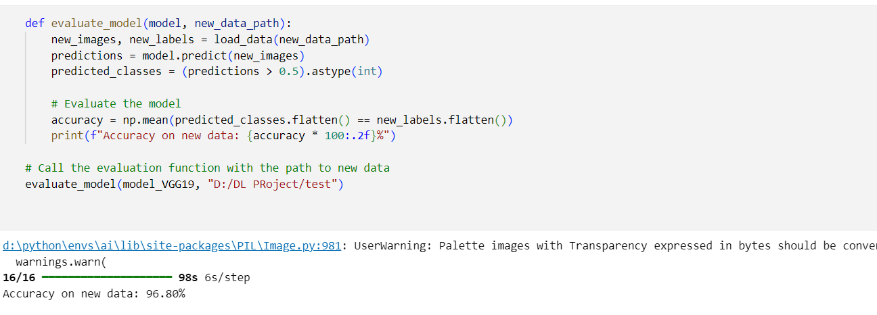

**Loss & Accuracy metrics for Model**

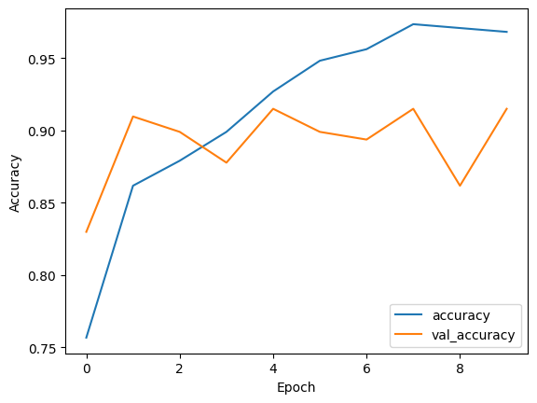

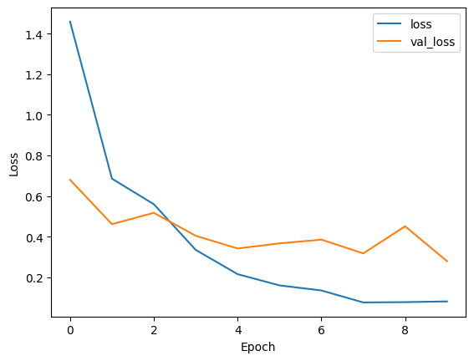

**Figure 17:** **Loss & Accuracy plots vs Epochs**

* **Building Interface**

**Building the User Interface with Streamlit**

For this project, we utilized **Streamlit** to create an intuitive and user-friendly web interface for our oral cancer detection application. Streamlit is an open-source app framework specifically designed for machine learning and data science projects, allowing developers to quickly build and deploy interactive applications.

**Why Streamlit?**

* **Simplicity:** Streamlit’s straightforward API enables rapid development without the need for complex web frameworks.
* **Interactivity:** It allows dynamic user input, such as uploading images, which the model can then analyze in real-time.
* **Integration:** Streamlit seamlessly integrates with popular Python libraries, making it ideal for deploying machine learning models and visualizing results.
* **Deployment:** With built-in support for deploying applications, Streamlit simplifies sharing our project with stakeholders and users, enhancing accessibility.

By leveraging Streamlit, we were able to focus on the model development and analysis while providing a polished, interactive interface for users to engage with the oral cancer detection system.

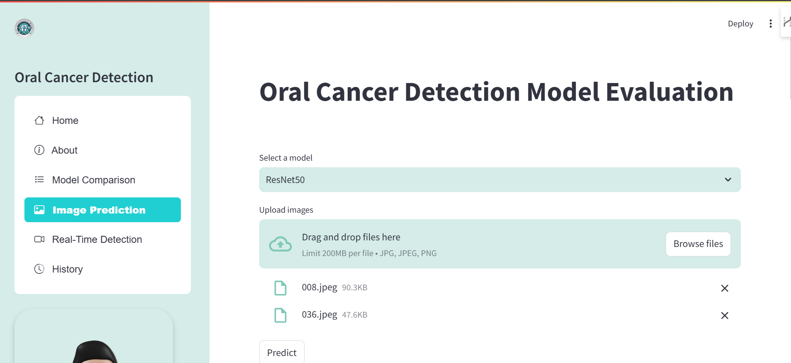

* **Deployment**

**1. Deployment on Streamlit Cloud**

The project has been deployed on **Streamlit Cloud** to make the oral cancer detection application accessible to users. The deployment process involved the following steps:

* **Pushed the Project to GitHub**: The complete codebase was uploaded to a GitHub repository, allowing version control and collaboration.
* **Deployed on Streamlit Cloud**: Using the GitHub repository, the project was deployed directly to Streamlit Cloud. This allows users to run the application in their web browser without any local setup.

Streamlit Cloud provides a seamless way to host applications, ensuring that users can easily interact with the model and visualize results.

**Live App!**

check the live app - <https://oral-cancer-detection-app.streamlit.app/>

**2. Deployment Using Docker**

In addition to Streamlit Cloud, we also utilized **Docker** for deployment. The Docker deployment process involved:

* **Creating a Dockerfile**: We created a Dockerfile that contains the instructions for building the Docker image, including the application's dependencies and configurations. Here is a sample Dockerfile:

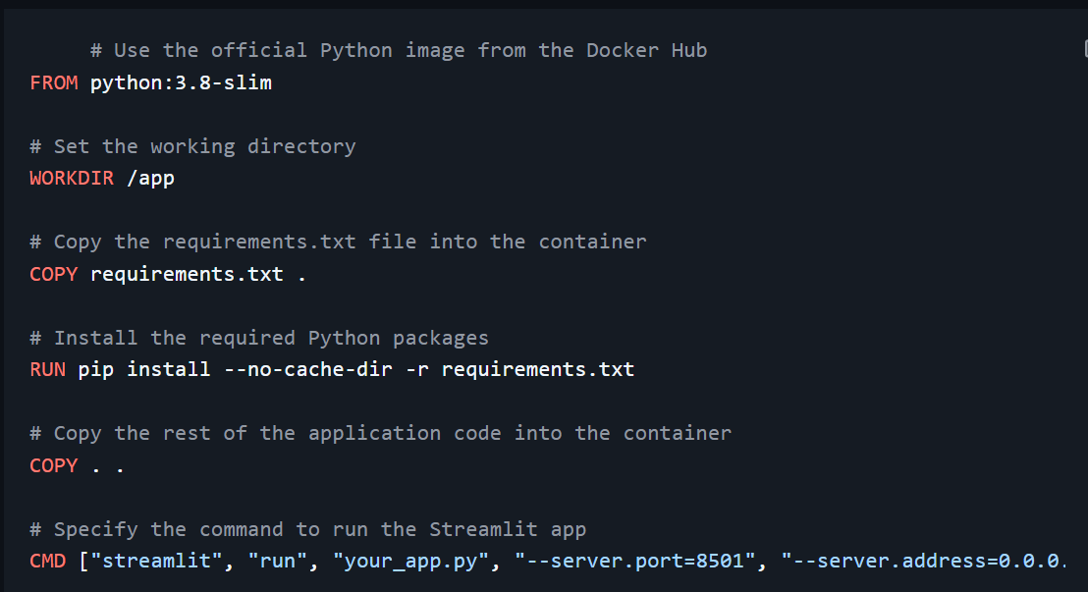

**Building Docker Images and Pushing to Docker Hub**

To build the Docker image and push it to Docker Hub, follow these steps:

1. **Build the Docker Image**: Run the following command in your terminal, ensuring you are in the directory containing your Dockerfile:

-docker build -t jagadesh086/my_streamlit_app:latest .

1. **Pushing to Docker Hub**

After creating the Docker image for the application, we pushed it to **Docker Hub** to enable easy access and deployment from anywhere. The steps to push the image are as follows:

1. **Login to Docker Hub**:

-docker login

1. **Push the Image**:

**-** docker push jagadesh086/my_streamlit_app:latest

**RESULTS**

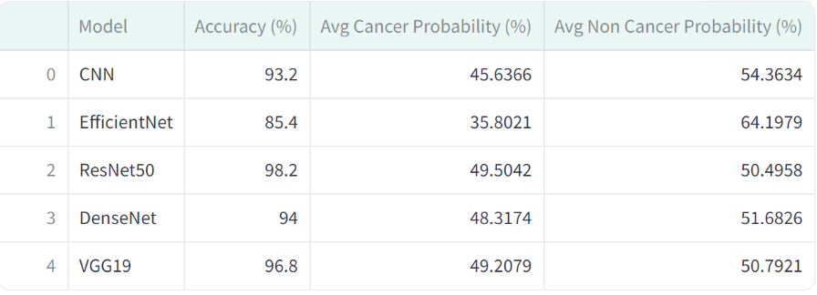

**Figure 18:Result**

**Observations:**

* As we know, during model training, a probability less than 0.5 indicates cancer, while a probability greater than 0.5 indicates non-cancer.
* ResNet50 showed the highest accuracy at 98.2%, with a balanced probability between cancer and non-cancer predictions.
* VGG19 performed well, achieving 96.8% accuracy, while maintaining a similar average probability for both cancer and non-cancer predictions.
* DenseNet121 also showed strong results, with 94% accuracy and relatively even probabilities.
* CNN displayed a solid accuracy of 93.2%, though its average cancer probability was lower compared to other models.
* EfficientNet achieved the lowest accuracy at 85.4%, but its non-cancer probability was the highest, making it more conservative in detecting non-cancer cases.

**SUMMARY**

The **Oral Cancer Detection** project utilizes deep learning algorithms, specifically **Convolutional Neural Networks (CNNs)**, alongside advanced architectures such as **ResNet50, DenseNet121, EfficientNetB2,** and **VGG19**, to identify oral cancer from medical images. These models consist of multiple layers that learn to extract and differentiate features from input images to classify them accurately.

The models were trained on a substantial dataset of labeled oral cancer and non-cancer images, enabling them to identify distinctive patterns associated with each class. Through the training process, these models adjusted their weights to minimize errors and enhance prediction accuracy.

During inference, a new medical image is processed by the trained model, which outputs a probability score. This score determines the likelihood of the sample being cancerous. For instance, if the probability is below 0.5, the sample is classified as cancerous; if above 0.5, it is classified as non-cancerous.

**Key Results**:

* **ResNet50** demonstrated the highest accuracy at **98.2%**, proving highly reliable in distinguishing cancerous from non-cancerous images.
* **VGG19** and **DenseNet121** also showed robust performance with **96.8%** and **94%** accuracy, respectively.
* The baseline **CNN model** achieved a commendable accuracy of **93.2%**.
* **EfficientNet**, though achieving the lowest accuracy at **85.4%**, was noted for its conservative approach in identifying non-cancer cases.

This project highlights the potential of deep learning models in assisting healthcare professionals by providing early and accurate detection of oral cancer, which could significantly enhance diagnostic processes and patient outcomes. Further research is essential to test these models on larger, more diverse datasets and validate their efficacy in real-world clinical settings.

**CONCLUSION**

In this project, we explored the use of deep learning models for detecting oral cancer from medical images. By evaluating models such as **CNN**, **ResNet50**, **DenseNet121**, **EfficientNetB2**, and **VGG19**, we found that:

* **ResNet50** achieved the highest accuracy of **98.2%**, making it the most reliable model for oral cancer detection in our experiments.
* **VGG19** also performed exceptionally well with an accuracy of **96.8%**, making it another strong candidate for deployment in real-world applications.
* Models like **DenseNet121** and **CNN** demonstrated solid performance, balancing accuracy with computational efficiency.
* **EfficientNetB2** was the most resource-efficient but had the lowest accuracy, indicating that it may be more suitable for cases where computational resources are limited and non-cancer detection is prioritized.

Overall, the models show great potential in assisting healthcare professionals with early detection of oral cancer, which is critical for improving patient outcomes. Moving forward, further fine-tuning and testing on more diverse datasets will help enhance model robustness and reliability.

**BIBLIOGRAPHY**

1. **Convolutional Neural Networks for Visual Recognition**  
   A foundational paper explaining the use of CNNs in image classification tasks:  
   *Krizhevsky, A., Sutskever, I., & Hinton, G. E.* (2012). "ImageNet Classification with Deep Convolutional Neural Networks." *Advances in Neural Information Processing Systems*, 25.
2. **ResNet: Deep Residual Learning for Image Recognition**  
   This paper covers the architecture of ResNet, which we used in our comparison.  
   *He, K., Zhang, X., Ren, S., & Sun, J.* (2016). "Deep Residual Learning for Image Recognition." *Proceedings of the IEEE Conference on Computer Vision and Pattern Recognition (CVPR)*.
3. **DenseNet: Densely Connected Convolutional Networks**  
   Explanation of DenseNet architecture, which is used for feature reuse:  
   *Huang, G., Liu, Z., Van Der Maaten, L., & Weinberger, K. Q.* (2017). "Densely Connected Convolutional Networks." *Proceedings of the IEEE Conference on Computer Vision and Pattern Recognition (CVPR)*.
4. **EfficientNet: Rethinking Model Scaling for Convolutional Neural Networks**  
   Description of the EfficientNet architecture used in our project.  
   *Tan, M., & Le, Q.* (2019). "EfficientNet: Rethinking Model Scaling for Convolutional Neural Networks." *Proceedings of the International Conference on Machine Learning (ICML)*.
5. **VGGNet: Very Deep Convolutional Networks for Large-Scale Image Recognition**  
   This research focuses on VGGNet, another model we compared.  
   *Simonyan, K., & Zisserman, A.* (2015). "Very Deep Convolutional Networks for Large-Scale Image Recognition." *International Conference on Learning Representations (ICLR)*.
6. **Streamlit Documentation**  
   Official documentation for Streamlit, which was used to build the interactive UI: [Streamlit Docs](https://docs.streamlit.io/)
7. **Docker Documentation**  
   Information on how to build and run containers for our project using Docker: [Docker Docs](https://docs.docker.com/)
8. **Kubernetes Documentation**  
   Official Kubernetes documentation for container orchestration: [Kubernetes Docs](https://kubernetes.io/docs/)
9. **TensorFlow Documentation**  
   Reference for TensorFlow, used in model training: [TensorFlow](https://www.tensorflow.org/)
10. **Scikit-Learn Documentation**  
    Documentation for Scikit-Learn, used for various ML-related tasks in this project: [Scikit-Learn Docs](https://scikit-learn.org/stable/)

**ANNEXURE**

Figure 1:Real Images Data -Page-5

Figure 2:CNN Model -Page-8

Figure 3:ResNet50 Model -Page-9

Figure 4:DenseNet121 -Page-10

Figure 5:EfficientNetB2 -Page-10

Figure 6:Vgg19 Model -Page-11

Figure 7:Oral Cancer Working model -Page-12

Flow Chart:Project Flow -Page-14

Figure 8:CNN model Architecture -Page-17

Figure 9:Loss & Accuracy plots vs epochs -CNN -Page-19

Figure 10:Confusion Matrix-cnn -Page-20

Figure 11:Performance Matrix-cnn -Page-20

Figure 12: Loss & Accuracy plots vs epochs -ResNet -Page-23

Figure 13: Confusion Matrix-Resnet -Page-24

Figure 14: Performance Matrix-ResNet -Page-24

Figure 15: Loss & Accuracy plots vs epochs-EfficientNet -Page-26

Figure 16: Loss & Accuracy plots vs epochs-DenseNet -Page-28

Figure 17: Loss & Accuracy plots vs epochs-Vgg19 -Page-30

Figure 18:Result -Page-33